SYSTEM DESIGN

Final Project: Patient Registry System

Misikir Mehari

2016

**Introduction**

The purpose of this Application is for registering patients in a clinical environment. It incorporates adding, deleting, searching and sorting of patients using different parameters. This application is written with java and the GUI component is written with javafx.

**Detailed Design**

1. **Class Diagram:**

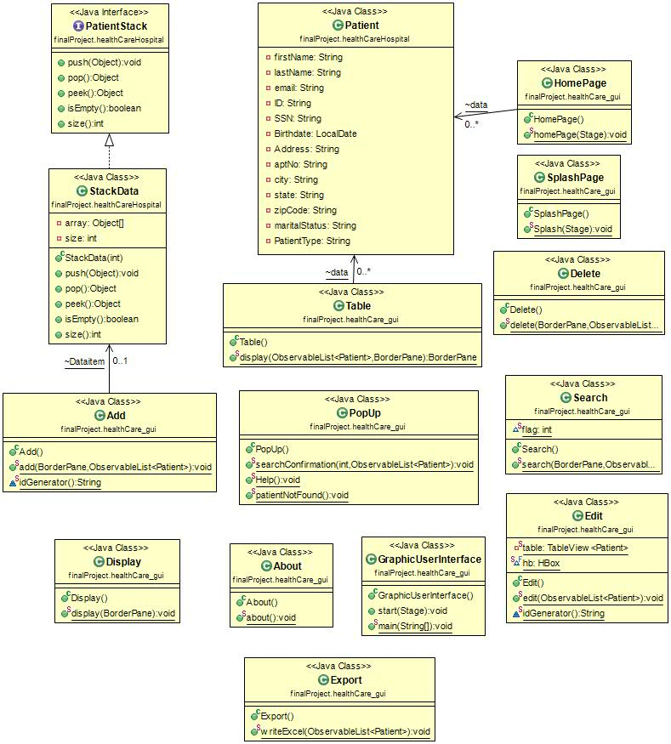

**Note:** The Class diagram has been minimized to incorporate in this design document. For detailed view please refer to the UML Diagram located in the source folder.

**2. Data Structure:**

* This application uses a stack of observable list to add patients. The StackData class is implemented from the patient stack interface and is used in the add class to add patients to the table.

**3. Design Patterns:**

* No specific design pattern has been implemented in this application. The Patient class is used to populate the Data in the table depending on user input.
* The Patient class is capable of creating both Emergency and non-emergency Patient based on the selection made by the user.

**System Development / Testing Environment**

This Application has been tested and the test document is included in the source folder. I have also tested the main class (Patient class) with Junit Testing and the test class is also located under the same folder. The limitations that were found after testing is mentioned in the next section.

**Limitations:**

* This application accepts input from a user in string format except Date of birth. In some cases, where the user input is not appropriate to the text fields, this application fails to catch that.
* When using search to find a patient, the user should always pass the search parameter. The application does not contain a default search parameter.

**References:**

* About.jpg: Image retrieved from <http://www.google.com>
* Healthcare.jpg: image retrieved from <http://www.google.com>
* helpicon.jpg: image retrieved from <http://www.google.com>
* icon.png.jpg: image retrieved from <http://www.google.com>